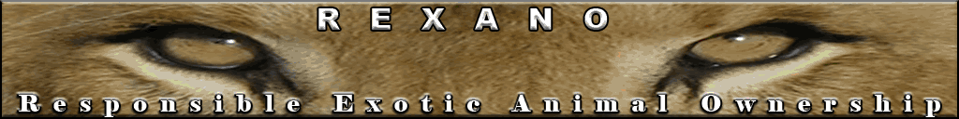

Photo Gallery of Non-Human Primates

The last few years has brought an increase in bans on the private ownership of non-human primates in the USA. The current trend is “fear of the unknown”; if it sounds exotic, then it needs to be banned. We are hoping to reverse this trend with this educational flyer on non-human primates.

Commonly Kept Captive Monkeys and Lemurs – partial list

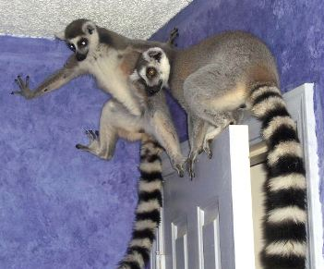 | 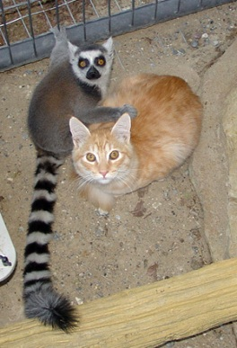 | Ring-Tailed Lemur  (Lemur catta)  Size: Head and body, 17.75 in (45 cm); Tail, 21.75 in (55 cm)  Weight: 5 to 7.5 lbs (2.3 to 3.4 kg)
 |  | Geoffroy's Marmoset  (Callithrix geoffroyi)  SIZE  Length: Body approximately 20 cm (8 in). Tail 26-28 cm (10-11 in)  Weight: 190-350 g  (0.4 - 0.77 lb)
   | 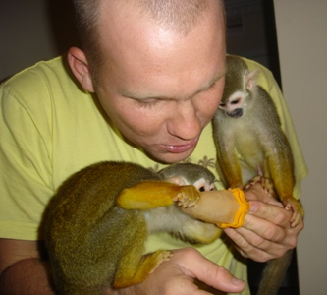    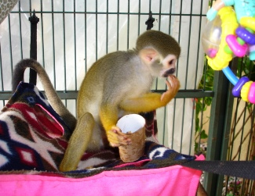 | Squirrel Monkey (Saimiri)  Height: 10.6 to 12.5 in (M & F)  Weight: 1.43 to 2.75 lb (M), 1.43 to 1.98 lb (F)
  Black-capped Capuchin  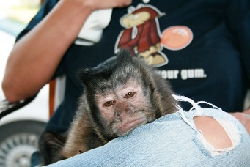   | 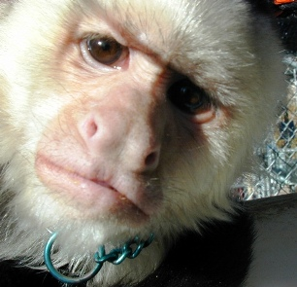  Black and White Capuchin    Black-capped Capuchin (above and on the left)  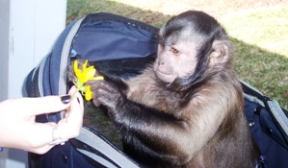 | Capuchin Monkey (Cebus)  Height: 17.48 in (M), 15.35 in (F)  Weight: 6.49 lb (M), 4.58 lb (F)  Capuchin Monkey (Cebus)  Height: 17.48 in (M), 15.35 in (F)  Weight: 6.49 lb (M), 4.58 lb (F)
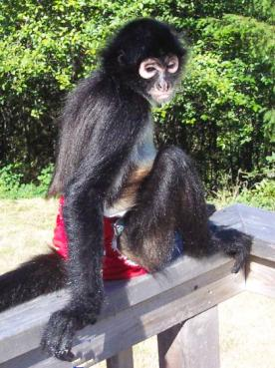  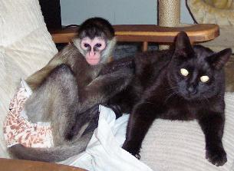 | 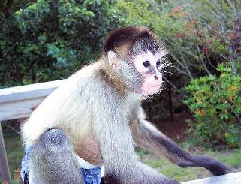  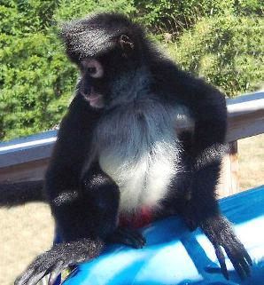 | Spider Monkey  (Ateles)  Height: 1.83 ft (M), 1.81 ft (F)  Weight: 23.8 lb (M), 21.3 lb (F)
  Pigtail macaque  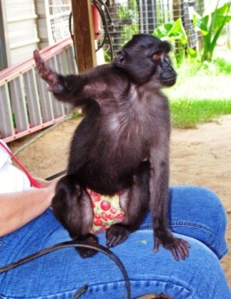  Black macaque  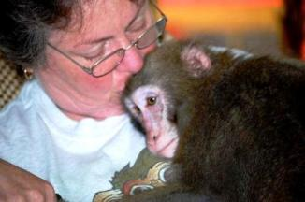  Japanese snow macaque    Java macaque | 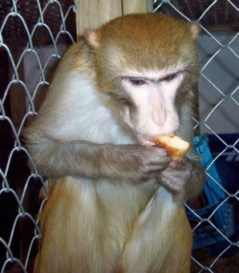  Rhesus macaque    Celebes crested macaque    Celebes crested macaque    Java macaque | Macaque Monkeys  Weight: 8 to 35 pounds depending on the gender and species  Head & Body: 15 to 31"
Copyright © REXANO 2009. Photos may not be reproduced without consent from REXANO www.REXANO.org

