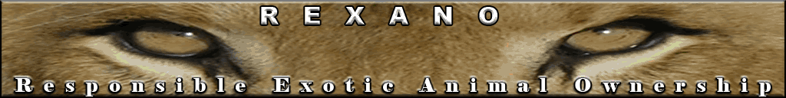

WINNER OF REXANO PRESIDENTAL CONTEST
By Anonymous, December 2008

Wow, where do you start? It’s something that should have been done all along by animal owners. The past regime has followed the path set before it and they, the path set before them. All have whittled away at personal rights of the people. To begin to take anything back you would need to consider the whole, even parts you are not a piece or party to.

First:
- Educate yourself
- Know what the factual risks are of private ownership of any animal
- Know your enemy, who and how they try to take away your rights
- Know the tactics used and be willing to respond

Second:
- Make yourself known
- Get to know all your state’s legislators possible by going to “meet greets”, open meetings, local party functions or other political happenings

Third-work:
- Work privately on anything you can do to preserve or take back ownership rights in everyday life while also working within group(s) that are TRULY of committed minds: KEEP AND PROTECT ANIMAL OWNER’S RIGHTS. There are already laws, regulations overload of people working to change legislation because they do not understand the difference between rights and welfare, proper animal husbandry versus raising a human.

Fourth:
- Communicate frequently – Always with a respectful and well thought out agenda, what you need to be heard. A “letter to the president” may not be read personally but every step you take to reach the top will eventually add to your voice. Taking people along with you is a good idea- gather them, grow them and hope for a bountiful harvest.

Winner’s Chosen REXANO Café press Golf Shirt: http://www.cafepress.com/REXANO.178958289

 www.REXANO.org

