

How would you educate our soon to be new president on our right to responsibly own animals of any type?

Deadline: December 1, 2008
Limit of 500 words
Send to: rexanomyspace@yahoo.com

Find choice of t-shirts here: http://www.cafepress.com/rexano

If you would rather have one of the many posters on a t-shirt look here:
http://www.rexano.org/Posters_JustSayNO/JSN_Gallery.htm

There are MANY nice ones to choose from!

View the website here: http://www.rexano.org

This is a very important topic due to his support of all animal rights backed and initiated legislation while Senator of Illinois. If we are going to keep our rights we need to know the issues, educate others and make our voice heard. Give it some thought and write to let us know your ideas! Hey, you have a chance to win a free t-shirt too!



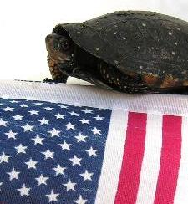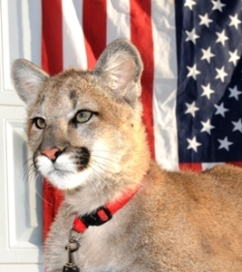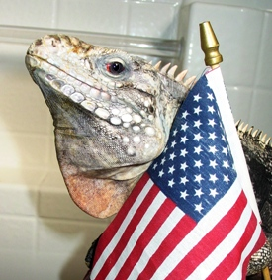

www.REXANO.org

