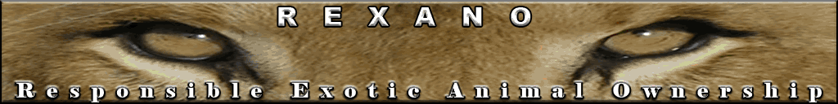

HUMAN FATALITIES CAUSED BY CAPTIVE EXOTIC ANIMALS IN FLORIDA 1990-2008

YEAR/Animal Species | Relationship to animal | Comments
2001 by Tiger | Tiger kills worker during cage repair at Savage Kingdom | Exhibitor, Savage Kingdom, has been shut down, Voluntarily accepted occupational hazard
2000 by Elephant | Ramos circus elephant killed a family member/acrobat Theresa Ramos | Voluntarily accepted occupational hazard
1998 by Tiger | Female owner at “Cat Dancers” show | Voluntarily accepted occupational hazard
1998 by Tiger | Tiger at “Cat Dancers” kills his male handler (and female owner few weeks apart, see above) | Voluntarily accepted occupational hazard
1994 by Tiger | Handler killed at AZA Miami Zoo, when a lock was left off a safety cage and the keeper stepped inside. | Voluntarily accepted occupational hazard
1993 by Elephant | Keeper killed at the AZA accredited Lowry Park Zoo in Tampa | Voluntarily accepted occupational hazard
1993 by Elephant | In Williston, circus trainer died after an elephant knocked him down at a Ringling Bros. and Barnum & Bailey Circus elephant farm | Voluntarily accepted occupational hazard
1990 by Elephant | In Ft. Lauderdale, an elephant with the Hanneford Family Circus crashed her handler to death after being startled by a passing car | Voluntarily accepted occupational hazard

Conclusion:

-In over 17 years, Florida had 8 fatal encounters with captive exotic animals, which is 0.5, half a death, per year.

-all fatalities happened to owners/trainers/handlers/workers as a result of occupational hazard which they voluntarily accepted, not any different than military, fire men, police, NASCAR drivers, etc…

-uninvolved public was not killed

-Two fatalities were at AZA accredited Metro and Lowry’s zoos which are often exempted from new regulations, even though AZA is a private (non governmental) accredited group.

-AZA zoos have more visitors than smaller non AZA exhibitors, so exempting them from new regulations while not exempting the rest in the name of ‘public safety’ is pure discrimination against non AZA exotic and wild animal owners.

-elephant related fatalities are expected to be higher in Florida than the rest of the nation since FL is the center for circuses. Same way you can expect to have more sled dogs and accidents in Alaska than in Florida.

www.REXANO.org

