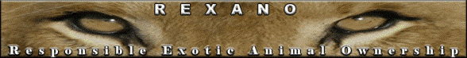
REXANO, 205 N. Stephanie Street, Suite D # 131, Henderson, Nevada 89074

REXANO CONTEST
www.REXANO.org

Why should HSUS, Humane Society of the United States, NOT be writing laws for animal owners?

Explain it as if you were telling a legislator, your neighbor, your friend or family member. Cite as many reasons, facts, past history and back up your information with references where possible. Explain it in as many or few words as needed.
The winning entry will be posted to the REXANO website, Facebook and Myspace pages plus you get the T-shirt of your choice from http://www.cafepress.com/rexano

Or choose a poster from our “Just Say NO” To Exotic Bans” gallery (5 pages) and we can put it on the T-shirt :
http://www.rexano.org/Posters_JustSayNO/JSN_Gallery.htm

If there are enough good entries of people trying to get the message out there a second and third place will be included.
C'mon! This is our biggest adversary in being able to legally own the animal of our choice and they don't care if someone is responsible or not- NO exotic ownership is what they strive for!

Deadline for entry is July 4, 2009
Email entries to rexanomyspace@yahoo.com

