

REXANO, www.REXANO.org Contest - Independence Day June 2008

Private Animal Owners- What have they done, what can they do, what could they do better and more of to help preserve private ownership in all areas and avenues?

Up to 500 word limit- it can be a eye opener for MANY- get your words
out there. It can be fewer words, just make your point, get it known.
Open to REXANO e-list members, MySpace or Facebook friends - or even your
neighbor! Winner will receive their choice of a T-shirt from the REXANO
Café press store: http://www.cafepress.com/rexano

The word is getting around- make yours part of it and protect your own and your right to own.
Email to rexanomyspace@yahoo.com
Deadline for submissions: July 4th, 2008

If you are a winner of our new contest and see REXANO poster you like but it is not on the Café press T-shirt yet, we can put any poster on the T-shirt for the winner.
http://www.rexano.org/Posters_JustSayNO/JSN_Gallery.htm

Last contest winner’s entry is here: http://www.rexano.org/animal_united_Frame.htm

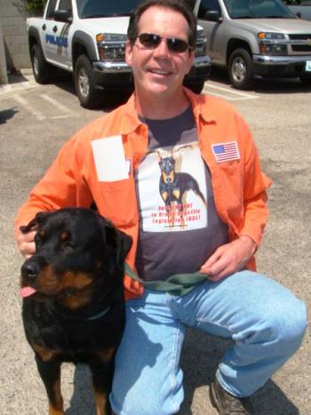

Last contest winner Eric wearing T-shirt from REXANO!!! Stop Breed Specific Legislation!!! Photo taken with a dog that was available for adoption at the Burbank Animal Shelter, June 2008.

